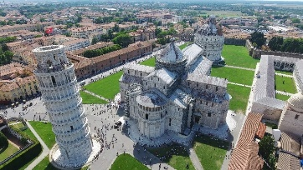
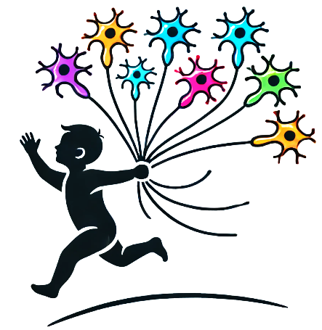
International meeting:
Artificial Intelligence driving research and cure in ALS and other Motor Neurone Diseases

March 21st-22nd, 2025
Pisa, Italy

General topics: Phenotypic determinants, Natural history prediction, Diagnostic flow charts, Pathogenic mechanisms, Therapeutic approaches and druggable molecules, Assistive technology and the Smart City

SCIENTIFIC PROGRAM draft
March 21, 2025

8.45-9.00: participants’ registration
8.45-9.30: Authorities welcoming

Session 1: Big data analysis for population-based studies
9.30-9.50 ALS epidemiology: from genetics to environmental risk factors in population-based studies A.Giugno and S. Giannoni (Bari-Tricase, Italy)
9.50-10.10 Big data for human phenotype ontology in neuromuscular diseases: from disease registries to precision medicine A. Atalaia (Paris, France)
10.10-10.30 Unravelling pathogenic role of habits and metabolic factors C. Lunetta (Pavia, Italy)
10.30-10.50 Federated learning: a new strategy for artificial intelligence stepforward (to be assigned)
10.50-11.10 discussion
11.10-11.30 coffee break

Session 2 Artificial intelligence for phenotype determinants analysis and natural history prediction
11.30-11.50 Machine Learning for ALS phenotype stratification U. Manera (Turin, Italy)
11.50-12-10 EEG-derived functional network disruption in ALS cognitive phenotypes Marjorie Metzger (Dublin, Ireland)
12.10-12.30 Machine learning for speech analysis A. Bandini (Pisa, Italy)
12.30-12.50 Gait analysis in ALS and other motorneurone diseases to be assigned
12.50-13.10 Modeling new phenotypes with disease modifying therapies in SMA G. Coratti (Rome, Italy)
13.10-13.30 discussion
13.30-14.30 lunch

Session 3. Timely and differential diagnosis issues
14.30-14-50 Connectomics and tractography in motor neuron diseases E. Spinelli (Milan, Italy)
14.50-15.10 -Deep learning predictions of survival based on brain and spinal cord MRI morphometry H. Westeneng (Utrecht , Netherlands)
15.10-15.30 Biological marker development Iacoangeli A (London, UK)
15.30-15.50 Machine Learning for Supporting Diagnosis of ALS and SMA with electromyography B. Sleutjes (Utrecht , Netherlands)
15.50-16.10 discussion
16.10-16.30 coffee break

Session 4 Artificial Intelligence and robotics in supporting treatment and assisting patients with motor neuron diseases
16.50-17.10 Robotics in assisting patients’ life : T. Proietti (Pisa, Italy)
17.10-17.30 Artificial intelligence in telemonitoring and in telemedicine S. Attarian (Marseille, France)
17.30-17.50 Virtual reality in digital tools in SMA V. Sansone (Milan, Italy)
Discussion
Poster with wine & cheese

__________________________________________

March 22, 2025
Session 5 Modelling pathogenetic mechanisms towards new treatment avenues
9.00-9.20 Digital analyses in advanced tissue models and organoids: the role of proteomics L.Ottoboni (Milan, Italy)

9.20-9.40 Systems-Level Functional Connectivity Biomarker Signature in ALS to be assigned

9.40-10.00 Artificial Intelligence for genetic and genomic data interpretation in ALS N. Ticozzi (Milan,Italy )

10.00-10.20 Multiomics and machine-learning identify novel transcriptional signatures in ALS Catanese A (Ulm, Germany)

10.20-10.40 Machine learning and data analysis towards new molecules development McFarlane (Dublin, UK)
10.40-11.00 discussion
Coffee break

Session 6 One health future perspectives in MND: from lab to smart daily leaving: a round table
Round table to be assigned

Local organizing Committee: Gabriele Siciliano, Andrea Bandini, Francesca Bianchi, Cecilia Carlesi, Luca Fanucci, Michelangelo Mancuso, Dino Pedreschi, Giulia Ricci, Sabrina Sacconi, Erika Schirinzi

General information
free registration.
Abstracts deadline: 25 January 2025.
Further information and hotel accommodation at: info@fclassevents.com

